**Week 3 Lab Report**

This document contains the template you will use to complete this assignment. Save the file by adding your last name to the filename (e.g. CIS246_W3_Lab_Report_EK_Smith.docx).

Follow the steps for this week’s lab. At various points in the instructions, you will be asked to answer a question or capture a screenshot to document your work – type your answers and place screenshots into this document, then submit this completed Lab Report to the appropriate weekly Dropbox.

***Screenshots***

#1. Show the permissions for Server Operator

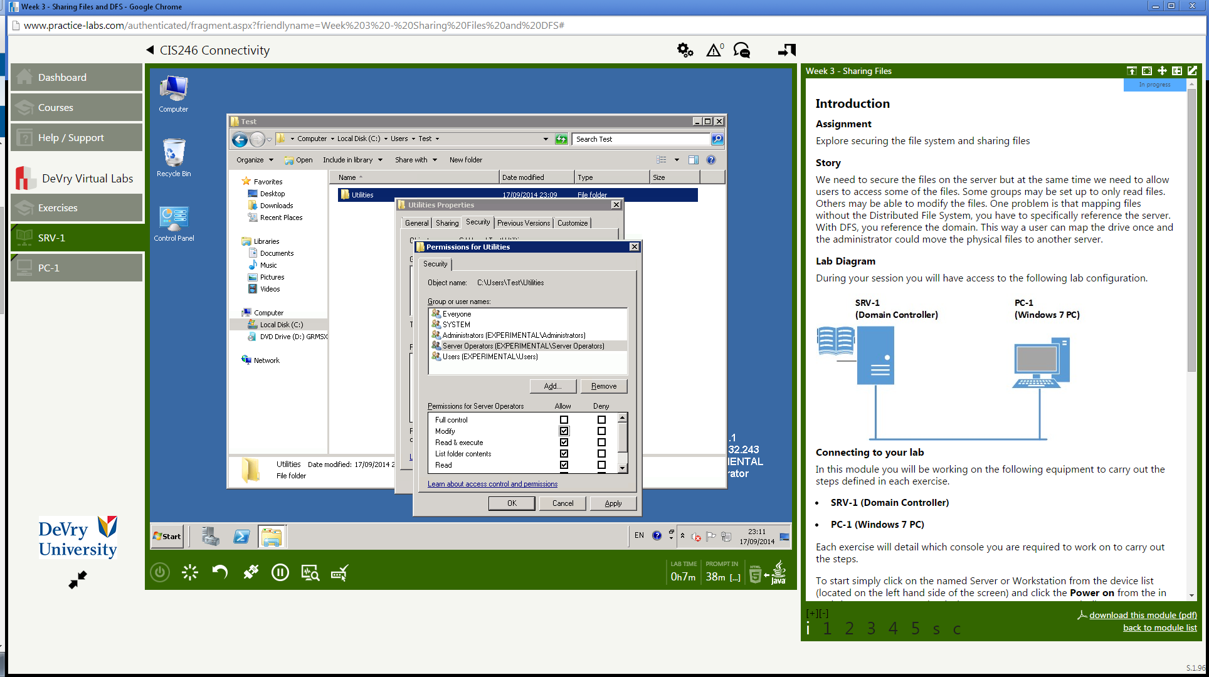

#2. Show the Utilities Properties window

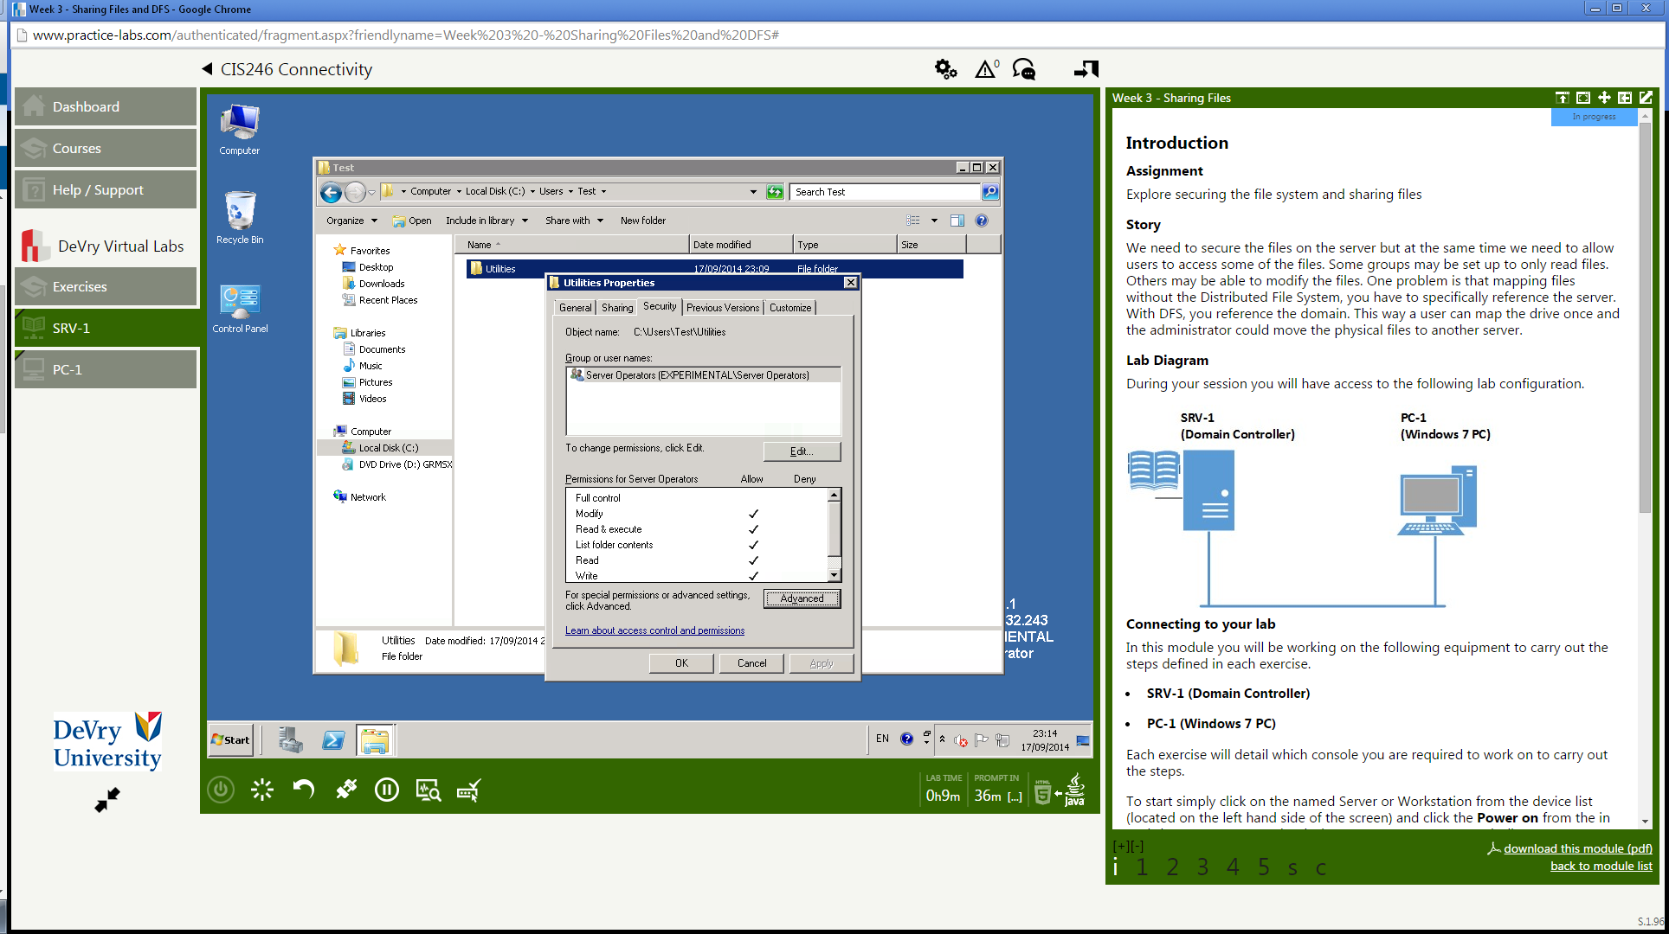

#3. Show the error message

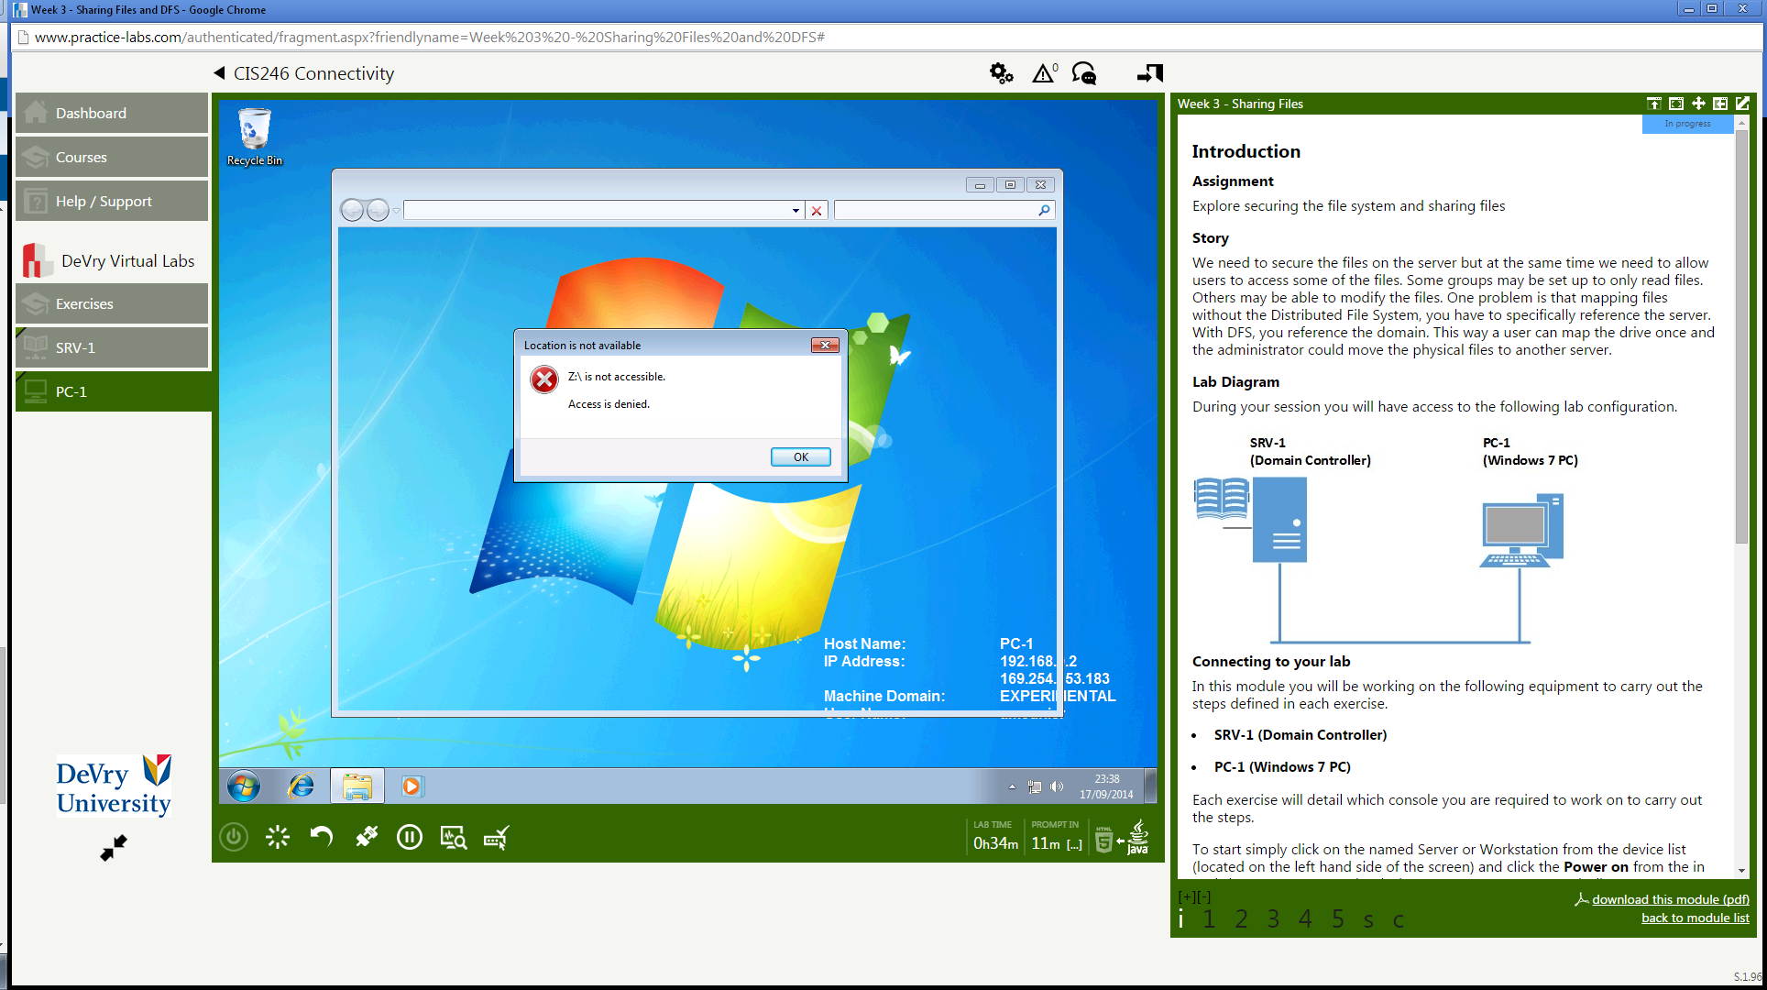

#4. Show your name and show the error message

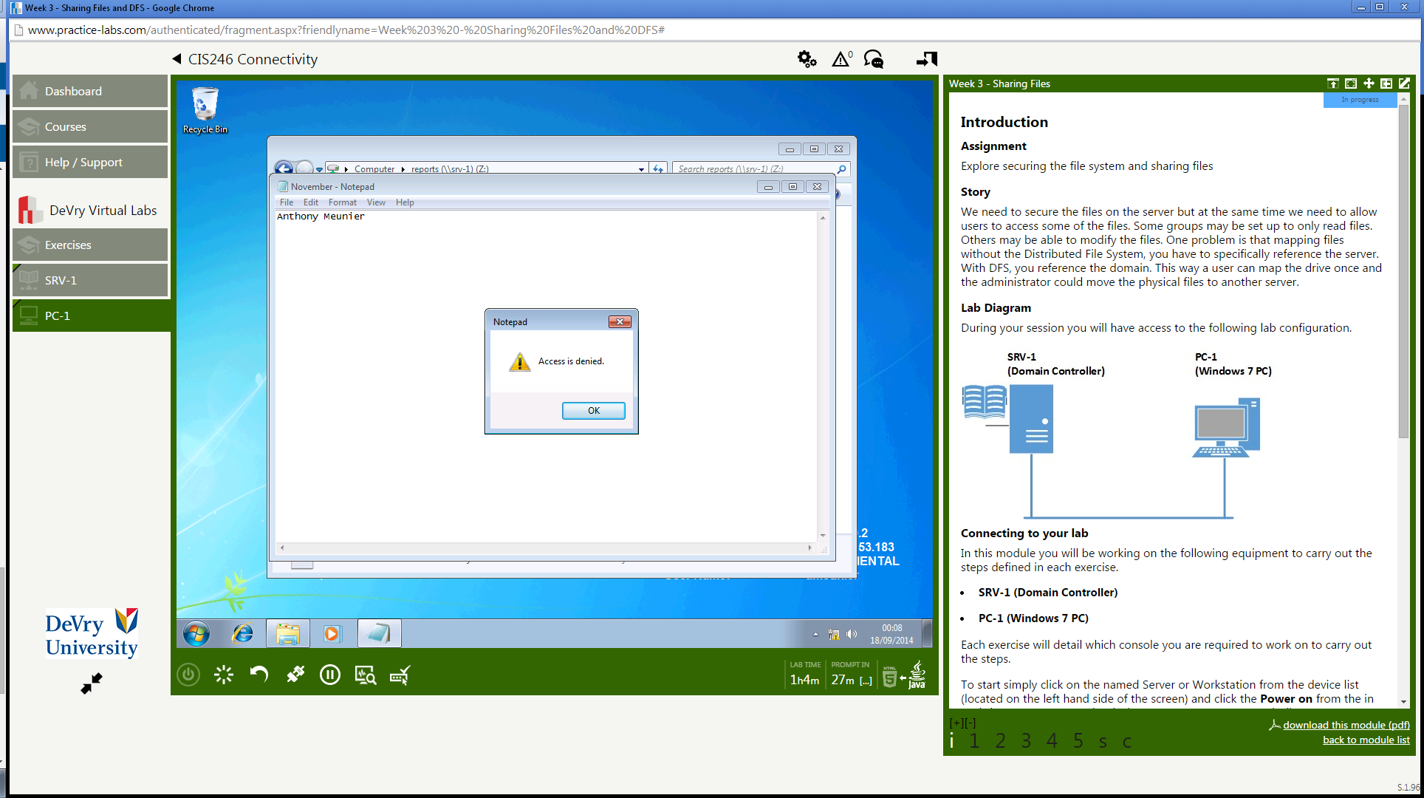

#5. Show that the drive is R: and the size is 1 KB

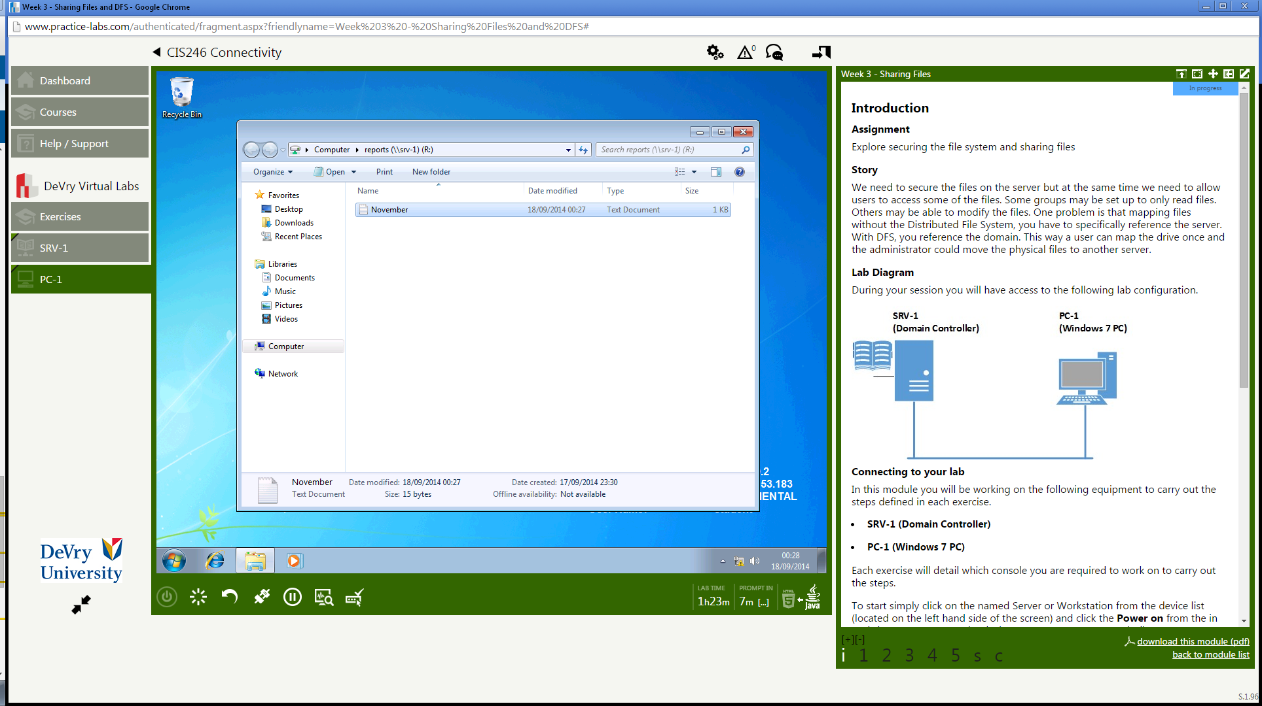

#6. Show the November text file with the letter Z: in the text box at the top of the window

